A close up of a piece of paper

Description generated with high confidence

CERTIFICATE of DEDICATION

*This certifies that*

**ISAIAH DANE E. YECYEC**

*WAS DEDICATED TO GOD*

At Escultor Residence Francia Compound, Purok 1, Magsilom, Cantilan, Surigao Del Sur.

On the 5th day of December in the year of 2024.

Mother : Neizel Bonen O. Escultor

Father : Dave Mark G. Yecyec

Officiated by : Pastor Elven B. Lumalad

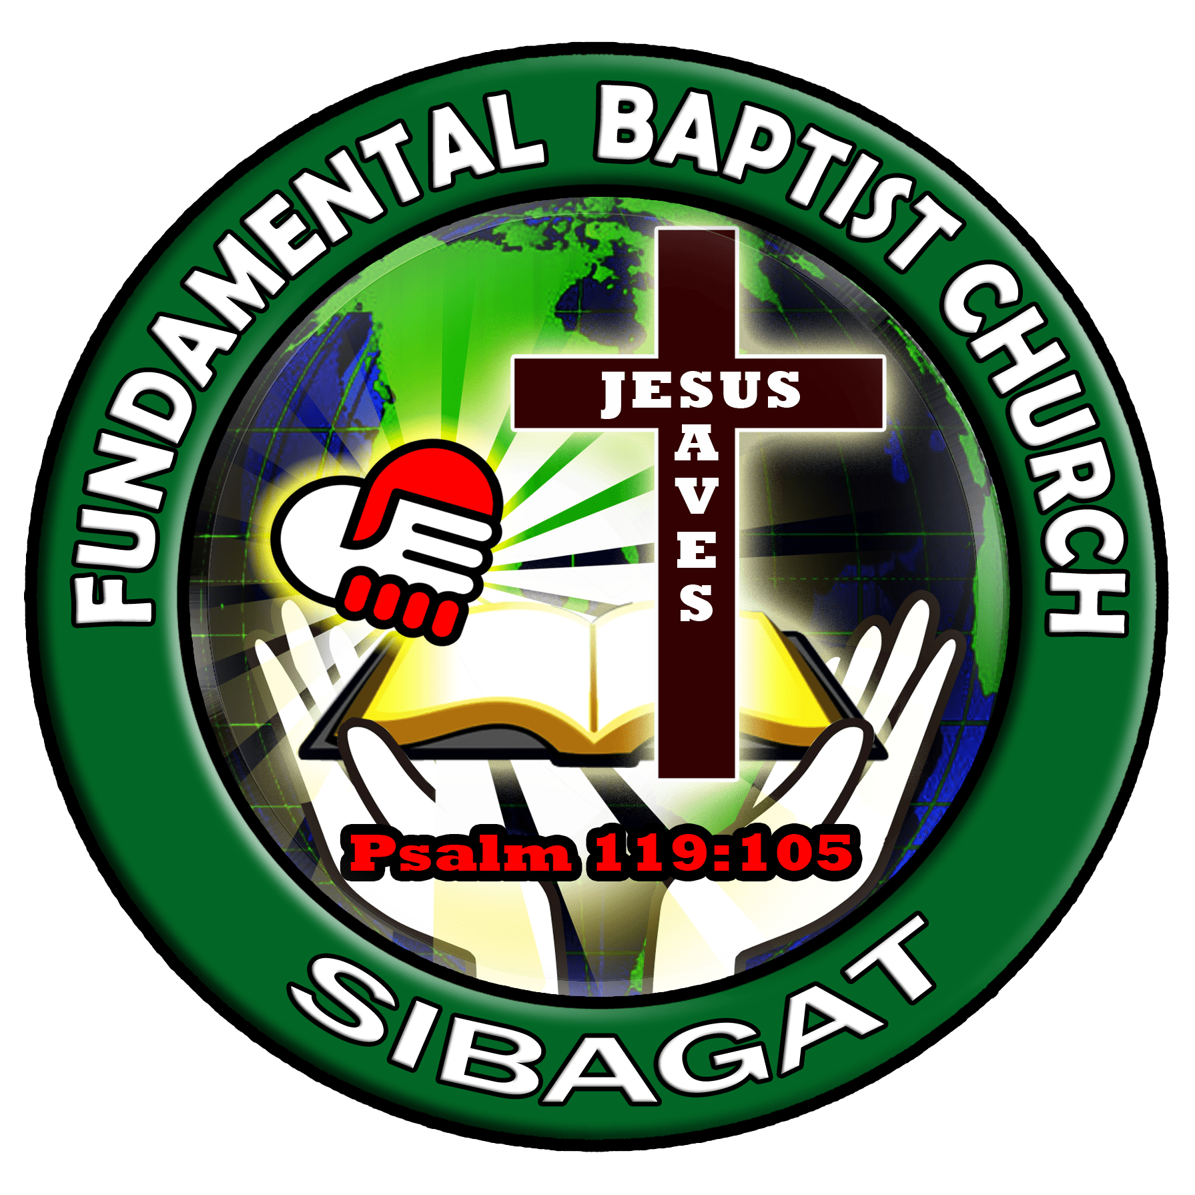



*“Let the little children come to me, and do not hinder them, for the Kingdom of God belongs to such as these.”*

*Mark 10:14 (NIV)*